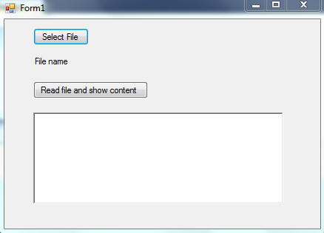

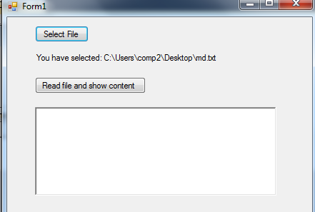

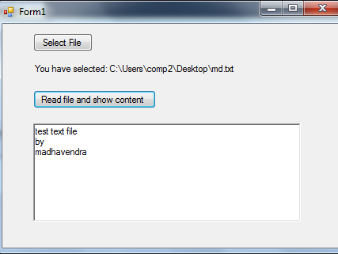

Imports System.IO

Imports System.IO

Public Class Form1

Private Sub Button1_Click(ByVal sender As System.Object, ByVal e As System.EventArgs) Handles Button1.Click

OpenFileDialog1.Filter = "txt files (*.txt)|*.txt|All files (*.*)|*.*"

OpenFileDialog1.InitialDirectory = "C:\"

OpenFileDialog1.Title = "Please select a text file."

If OpenFileDialog1.ShowDialog <> Windows.Forms.DialogResult.Cancel Then

Label1.Text = "You have selected: " & OpenFileDialog1.FileName

Button2.Enabled = True

End If

End Sub

Private Sub Button2_Click(ByVal sender As System.Object, ByVal e As System.EventArgs) Handles Button2.Click

Try

Using sr As New StreamReader(OpenFileDialog1.FileName)

Dim line As String

line = sr.ReadToEnd()

RichTextBox1.Text = line

End Using

Catch exp As Exception

MsgBox(exp.Message)

End Try

End Sub

End Class